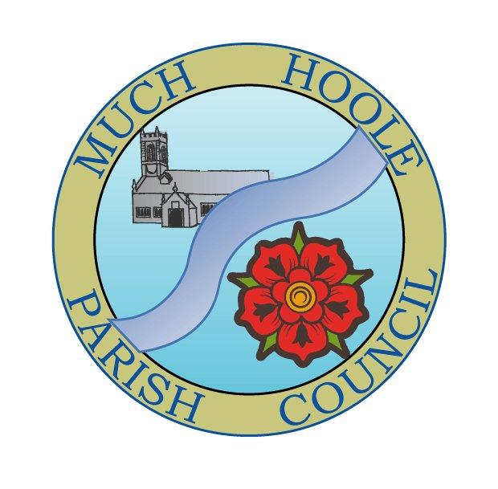 | MUCH HOOLE PARISH COUNCIL  NOTICE OF MEETING
You are hereby summoned to attend the Annual Meeting of Much Hoole Parish Council to be held on Monday 13th June 2022 at 7.30pm. The meeting will be held at the Venue (Hoole Memorial Village Hall), Liverpool Old Road.

Russ Weaver, Clerk to the Parish Council

AGENDA
1 | Apologies for Absence  To receive apologies for absence: Cllr Cocker, Cllr Taylor
2 | Declaration of Interests and Dispensations  - To receive declarations of interest from Councillors on items on the agenda  - To receive written requests for dispensations for disclosable pecuniary interests (if any)  - To grant any requests for dispensation as appropriate
3 | Minutes of the Previous Meetings  To resolve to approve as a correct record the Minutes of the Council Meeting held on the 9th May 2022
4 | Public Time  To invite and listen to issues raised by members of the public.
5 | Planning  There are no relevant planning applications or decisions relating to Much Hoole
6 | Off Road Cycle Track  To consider any updates on the Cycle track and resolve any actions required.
7 | Finance and audit  To authorise payment of the following:  - To Resolve to pay Clerk salary for May in sum of £240 (net for May)  - To Resolve to re-imburse Clerk in sum of £9.45 for mileage  - To Resolve to pay HMRC in sum of £60 PAYE for May  - To Resolve to pay Ian Edwards for internal audit services in the sum of £100  - To note and approve the internal audit report  - To note and accept the statement of governance  - To note and agree the statement of accounts  - To set the period of public rights to view unaudited accounts as:  Monday 20th June to Friday 29th July 2022
8 | Community led projects  To discuss and update progress on the spending of community funding.  To consider a proposal by Councillor Hewitt to establish a community fruit garden at an approximate cost of £500. (see paper attached to agenda papers)
9 | Footpaths  The Council is asked to note that Councillor Cocker has informed LCC it can delete the request to repair the footbridge on FP22, given that Parish Councillors and volunteers have made the repairs themselves rather than wait for LCC to take action.
10 | Much Hoole Village Hall  To receive an update on the activities and progress of the Venue.
11 | LCC and Parish Council working Charter  Representatives of Parish Councils and LCC have produced a charter documenting how they can work effectively together. The Council is asked to endorse and note the Charter
12 | Grants  The Council is asked to note that the work to improve access lighting to the Scout hut, which was underwritten by a grant to the Scouts of £2,000, has come in considerably under budget. However, the Scouts have indicated that they will submit a further proposal to improve access/egress to the fire exit area which will utilize the outstanding money. Neither the invoice nor the new grant application have been received, and the money therefore remains in the Council account earmarked for use as outlined above.
13 | Local Meetings  - To receive any reports from local meetings.  - To note any forthcoming meetings.  The next LALC executive meeting will be on the 21/6/22 by Zoom at 7pm.
14 | Items for the Next Agenda (for information only)
15 | Date of Next Meeting  The Parish Council to agree the date of the next meeting as 7.30pm Monday 11th July 2022.

